Locus of Points Equidistant from Two Lines

Definition
# Source: AI Source: Provided by: [Data Path: Persons Table -> ID Column: 1, Name_En Column: Motasem Essam] -> From: [ChatGPT] on [7/25/2026]
The locus of points equidistant from two intersecting lines is the set of all points whose perpendicular distances to the two lines are equal.
If $l_{1}$and $l_{2}$are two intersecting lines and $P$is a point, then:
$$\boxed{d\left(P , l_{1}\right)=d\left(P , l_{2}\right)}$$
The locus consists of the two angle bisectors formed by the two lines.
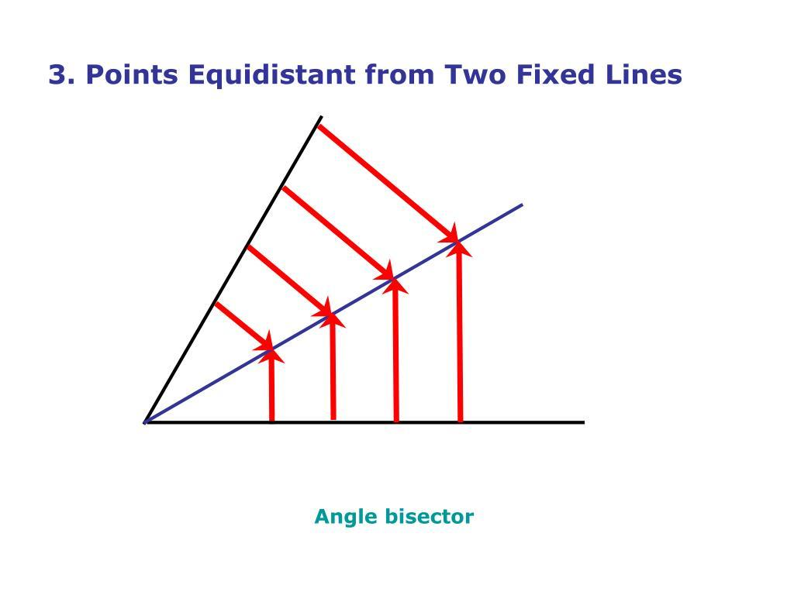
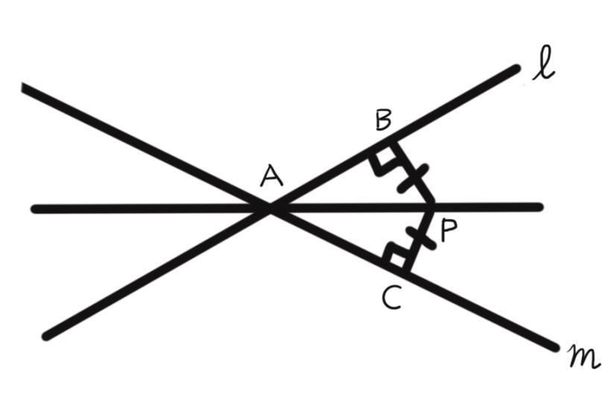
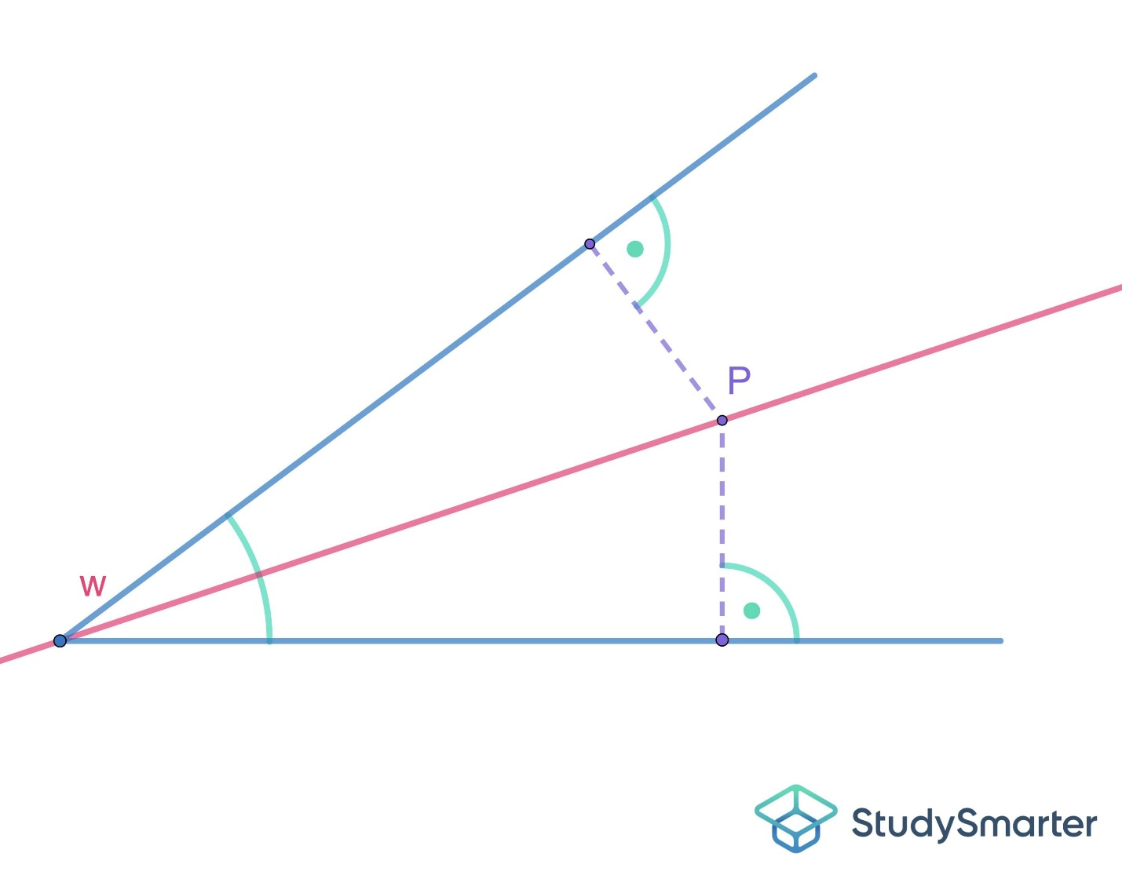
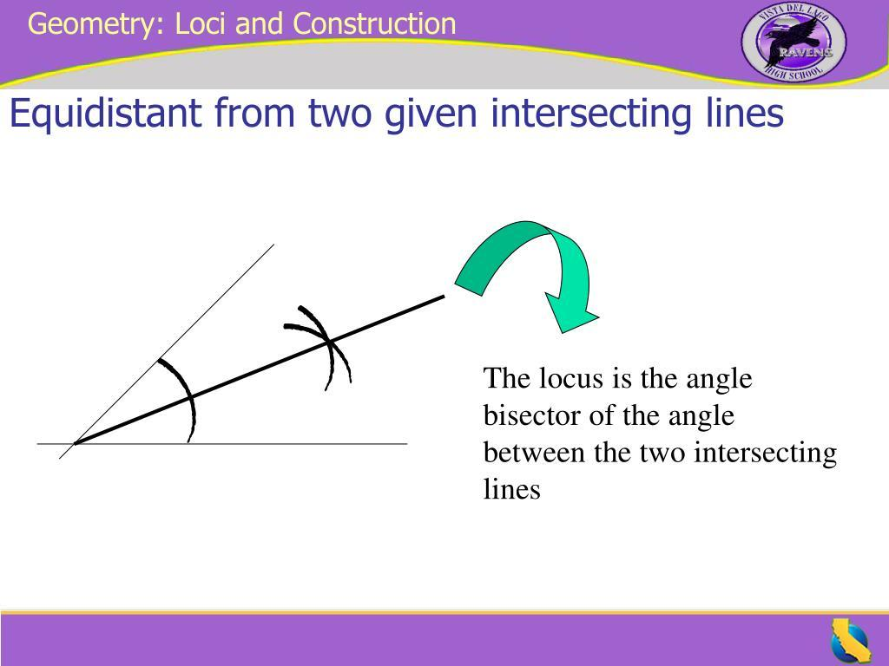

Simple Definition
# Source: AI Source: Provided by: [Data Path: Persons Table -> ID Column: 1, Name_En Column: Motasem Essam] -> From: [ChatGPT] on [7/25/2026]
The locus of points equidistant from two intersecting lines is the pair of angle bisectors of the angles formed by the two lines.
If two lines intersect at $O$, they form four angles. The two angle-bisector lines pass through $O$and divide those angles into equal halves.
Thus:
$$\boxed{\text{Equal Distance from Two Intersecting Lines}→\text{Two Angle Bisectors}}$$

Fundamental Concept
# Source: AI Source: Provided by: [Data Path: Persons Table -> ID Column: 1, Name_En Column: Motasem Essam] -> From: [ChatGPT] on [7/25/2026]
Suppose two lines $l_{1}$and $l_{2}$intersect at $O$.
For a point $P$, let:
- $PA$be the perpendicular distance from $P$to $l_{1}$,
- $PB$be the perpendicular distance from $P$to $l_{2}$.
The condition for the locus is:
$$\boxed{PA=PB}$$
This happens exactly when $P$lies on one of the two angle bisectors.
Therefore:
$$\boxed{d\left(P , l_{1}\right)=d\left(P , l_{2}\right) ⟺ P\text{ lies on an angle bisector of }l_{1}\text{ and }l_{2}}$$

Main Structure
# Source: AI Source: Provided by: [Data Path: Persons Table -> ID Column: 1, Name_En Column: Motasem Essam] -> From: [ChatGPT] on [7/25/2026]
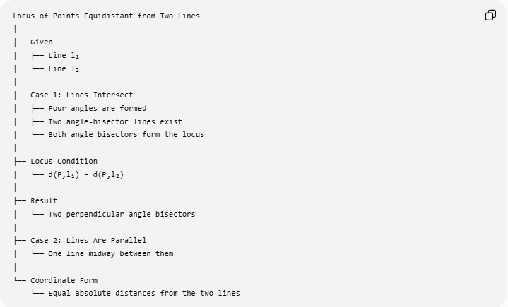
Locus of Points Equidistant from Two Lines
│
├── Given
│ ├── Line l₁
│ └── Line l₂
│
├── Case 1: Lines Intersect
│ ├── Four angles are formed
│ ├── Two angle-bisector lines exist
│ └── Both angle bisectors form the locus
│
├── Locus Condition
│ └── d(P,l₁) = d(P,l₂)
│
├── Result
│ └── Two perpendicular angle bisectors
│
├── Case 2: Lines Are Parallel
│ └── One line midway between them
│
└── Coordinate Form
└── Equal absolute distances from the two lines

Why Are There Two Angle Bisectors?
# Source: AI Source: Provided by: [Data Path: Persons Table -> ID Column: 1, Name_En Column: Motasem Essam] -> From: [ChatGPT] on [7/25/2026]
Two intersecting lines form four angles:
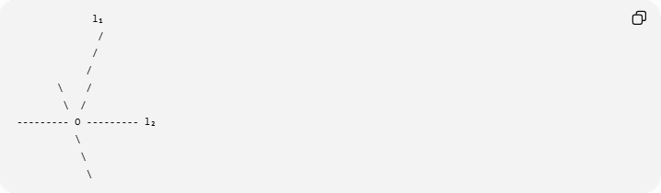
l₁
/
/
/
\ /
\ /
--------- O --------- l₂
\
\
\
There are two pairs of vertical angles.
Each pair has its own angle bisector.
Therefore, there are two angle-bisector lines.
These two lines are perpendicular:
$$\boxed{{\text{Angle Bisector}}_{1}⊥{\text{Angle Bisector}}_{2}}$$
Both belong to the locus.

Example
# Source: AI Source: Provided by: [Data Path: Persons Table -> ID Column: 1, Name_En Column: Motasem Essam] -> From: [ChatGPT] on [7/25/2026]
Suppose two lines intersect at $O$and form angles of:
$${60}^{∘}, {120}^{∘}, {60}^{∘}, {120}^{∘}.$$
The bisector of each ${60}^{∘}$angle divides it into:
$${30}^{∘}+{30}^{∘}.$$
The bisector of each ${120}^{∘}$angle divides it into:
$${60}^{∘}+{60}^{∘}.$$
The two complete angle-bisector lines are therefore the locus.
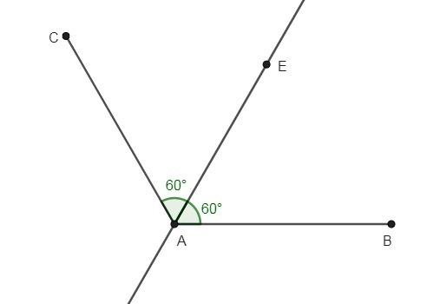
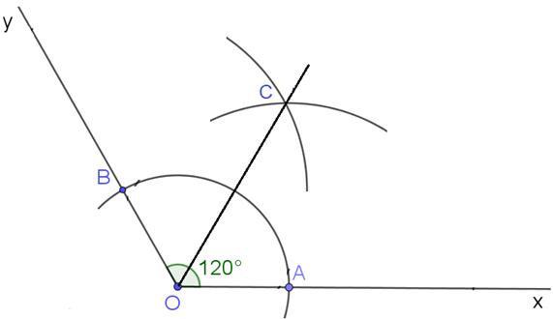
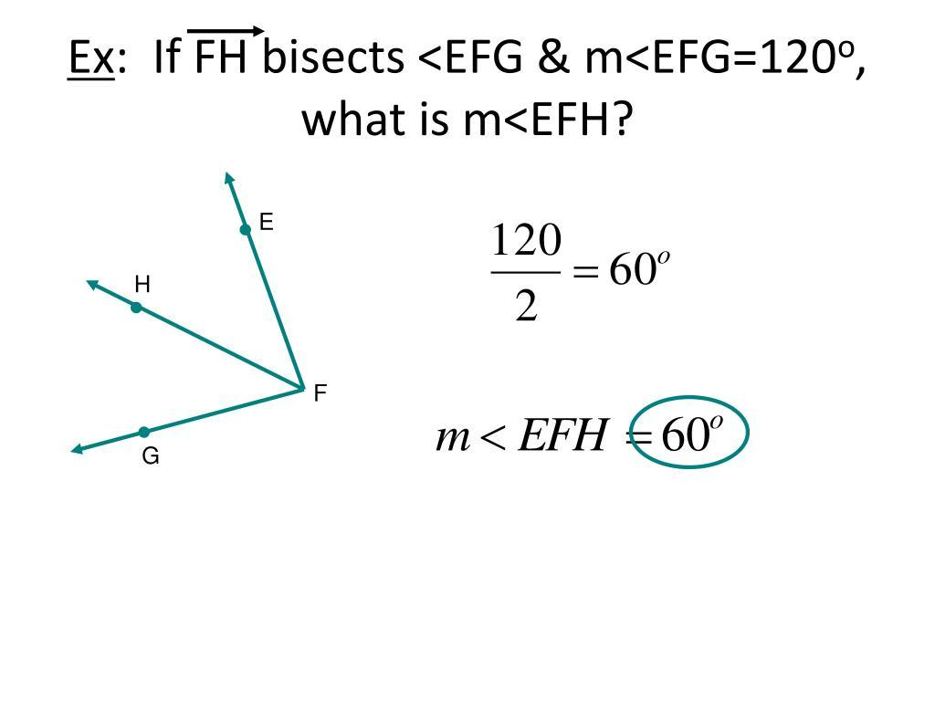

Geometric Proof
# Source: AI Source: Provided by: [Data Path: Persons Table -> ID Column: 1, Name_En Column: Motasem Essam] -> From: [ChatGPT] on [7/25/2026]
Let $P$lie on an angle bisector of two intersecting lines $l_{1}$and $l_{2}$.
Drop perpendiculars from $P$to the two lines:
$$PA⊥l_{1}$$
and
$$PB⊥l_{2}.$$
Because $P$lies on the angle bisector, the two angles at $P$are equal.
The two resulting right triangles have:
- equal hypotenuse $OP$,
- one equal acute angle,
- right angles.
Therefore, the triangles are congruent.
Hence:
$$\boxed{PA=PB}$$
So every point on an angle bisector is equidistant from the two lines.

Converse
# Source: AI Source: Provided by: [Data Path: Persons Table -> ID Column: 1, Name_En Column: Motasem Essam] -> From: [ChatGPT] on [7/25/2026]
Now suppose a point $P$has equal perpendicular distances from the two lines:
$$\boxed{d\left(P , l_{1}\right)=d\left(P , l_{2}\right)}$$
Construct the perpendicular segments from $P$to the lines.
The resulting right triangles have equal corresponding legs and a common hypotenuse.
Therefore, the triangles are congruent, giving equal angles at $P$.
Thus $P$lies on an angle bisector.
So:
$$\boxed{d\left(P , l_{1}\right)=d\left(P , l_{2}\right)⇒P\text{ lies on an angle bisector}}$$
Combining both directions:
$$\boxed{d\left(P , l_{1}\right)=d\left(P , l_{2}\right) ⟺ P\text{ lies on an angle bisector}}$$

Coordinate Geometry
# Source: AI Source: Provided by: [Data Path: Persons Table -> ID Column: 1, Name_En Column: Motasem Essam] -> From: [ChatGPT] on [7/25/2026]
Suppose the two lines are:
$$l_{1}:a_{1}x+b_{1}y+c_{1}=0$$
and:
$$l_{2}:a_{2}x+b_{2}y+c_{2}=0.$$
The perpendicular distance from a point $P=\left(x , y\right)$to a line
$$ax+by+c=0$$
is:
$$d=\frac{∣ax+by+c∣}{\sqrt{a^{2}+b^{2}}}.$$
Therefore, the locus satisfies:
$$\boxed{\frac{∣a_{1}x+b_{1}y+c_{1}∣}{\sqrt{a_{1}^{2}+b_{1}^{2}}}=\frac{∣a_{2}x+b_{2}y+c_{2}∣}{\sqrt{a_{2}^{2}+b_{2}^{2}}}}$$
Because of the absolute values, this produces two lines.

Example — Coordinate Lines
# Source: AI Source: Provided by: [Data Path: Persons Table -> ID Column: 1, Name_En Column: Motasem Essam] -> From: [ChatGPT] on [7/25/2026]
Consider:
$$l_{1}:y=0$$
and:
$$l_{2}:x=0.$$
These are the $x$-axis and $y$-axis.
For a point $P=\left(x , y\right)$:
Distance from the $x$-axis:
$$d\left(P , l_{1}\right)=∣y∣$$
Distance from the $y$-axis:
$$d\left(P , l_{2}\right)=∣x∣$$
Equidistance requires:
$$∣x∣=∣y∣.$$
Therefore:
$$x=y$$
or:
$$x=-y.$$
Thus the locus is:
$$\boxed{x=y \text{or} x=-y}$$
These are the two angle bisectors of the coordinate axes.
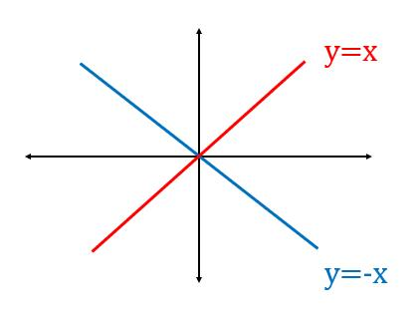
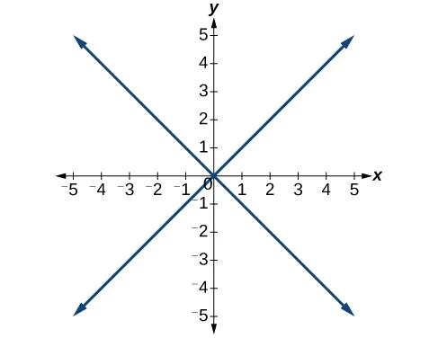
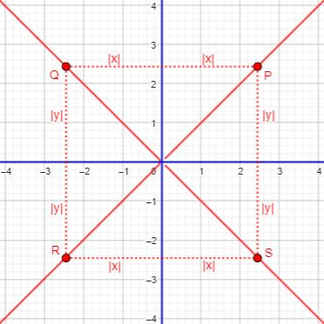
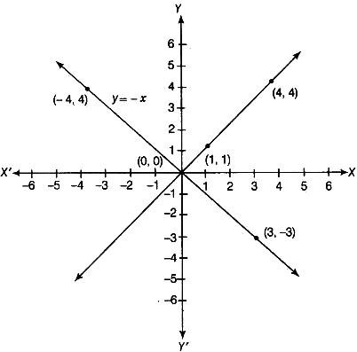

Parallel Lines — Important Special Case
# Source: AI Source: Provided by: [Data Path: Persons Table -> ID Column: 1, Name_En Column: Motasem Essam] -> From: [ChatGPT] on [7/25/2026]
If the two lines are parallel, they do not form angles.
Therefore, there are no angle bisectors.
Instead, the locus is one line halfway between the two parallel lines, parallel to both.
Suppose:
$$l_{1}:y=2$$
and:
$$l_{2}:y=8.$$
A point $\left(x , y\right)$is equally distant from both when:
$$∣y-2∣=∣y-8∣.$$
The midpoint between $2$and $8$is:
$$y=5.$$
Therefore, the locus is:
$$\boxed{y=5}$$
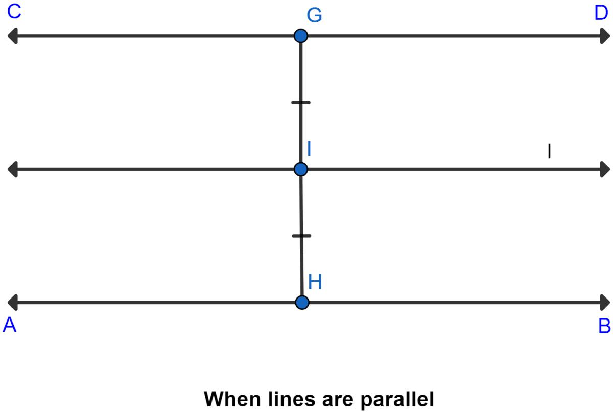
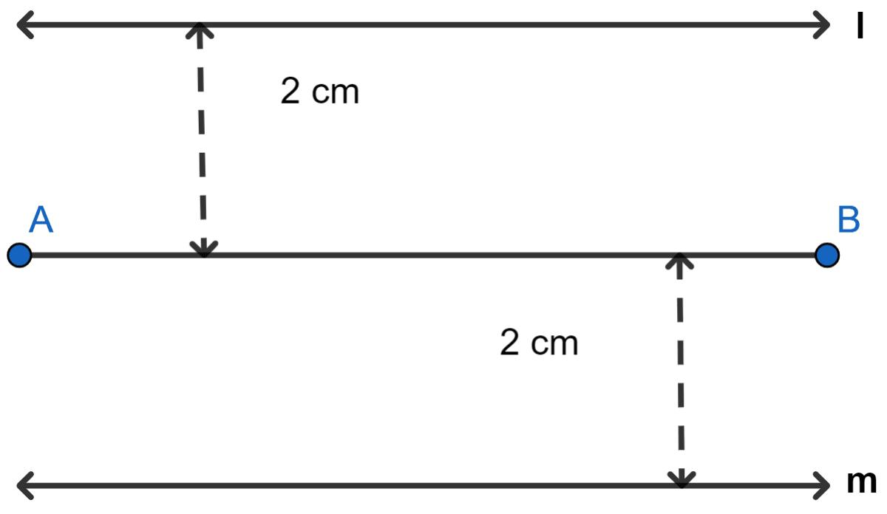
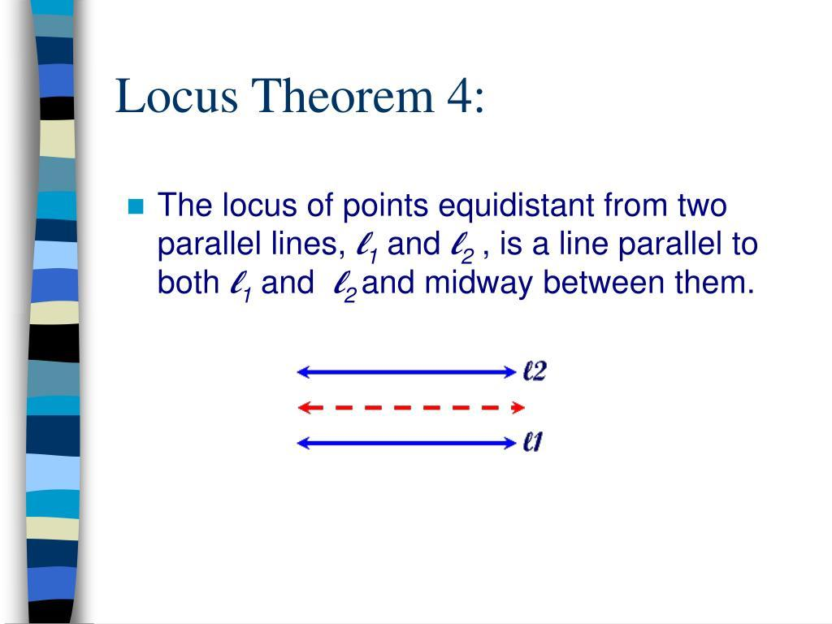
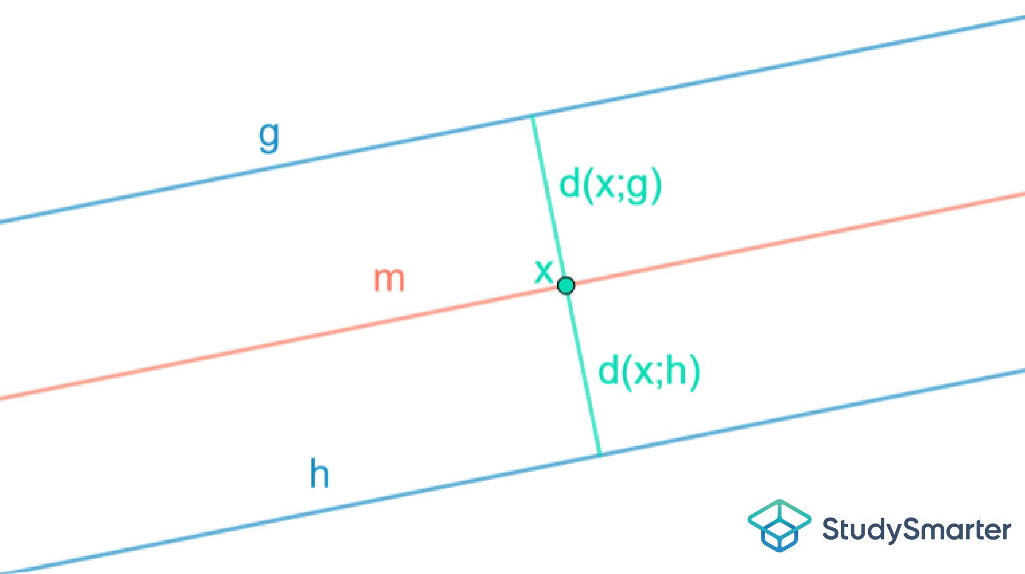

Intersecting vs. Parallel Lines
# Source: AI Source: Provided by: [Data Path: Persons Table -> ID Column: 1, Name_En Column: Motasem Essam] -> From: [ChatGPT] on [7/25/2026]
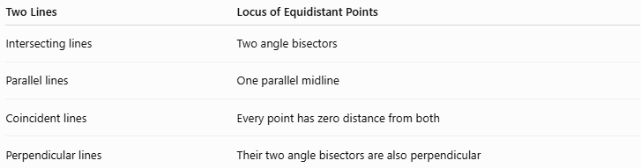
Two Lines | Locus of Equidistant Points
Intersecting lines | Two angle bisectors
Parallel lines | One parallel midline
Coincident lines | Every point has zero distance from both
Perpendicular lines | Their two angle bisectors are also perpendicular
For intersecting lines:
$$\boxed{\text{2 angle-bisector lines}}$$
For distinct parallel lines:
$$\boxed{\text{1 mid-parallel line}}$$

Relation to Angle Bisectors
# Source: AI Source: Provided by: [Data Path: Persons Table -> ID Column: 1, Name_En Column: Motasem Essam] -> From: [ChatGPT] on [7/25/2026]
This locus provides one of the fundamental characterizations of an angle bisector.
For two intersecting lines:
$$\boxed{P\text{ lies on an angle bisector }⟺ d\left(P , l_{1}\right)=d\left(P , l_{2}\right)}$$
This is why angle bisectors are sometimes defined using equal perpendicular distances.

Relation to Triangle Geometry
# Source: AI Source: Provided by: [Data Path: Persons Table -> ID Column: 1, Name_En Column: Motasem Essam] -> From: [ChatGPT] on [7/25/2026]
This concept is particularly important in triangles.
Consider two sides of a triangle meeting at vertex $A$:
$$AB$$
and:
$$AC.$$
The angle bisector of:
$$∠BAC$$
is the locus of points equidistant from the two lines $AB$and $AC$.
For all points $P$on the angle bisector:
$$\boxed{d\left(P , AB\right)=d\left(P , AC\right)}$$
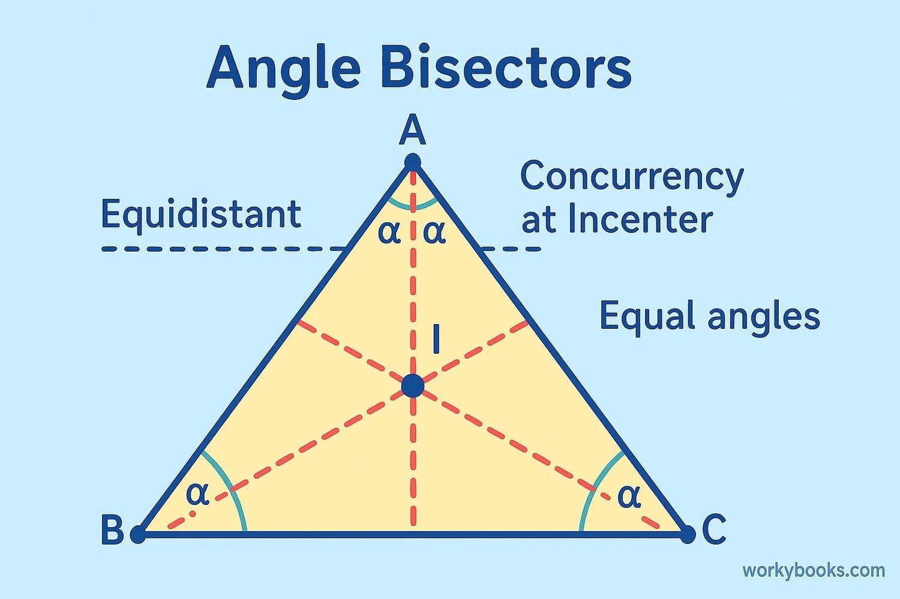
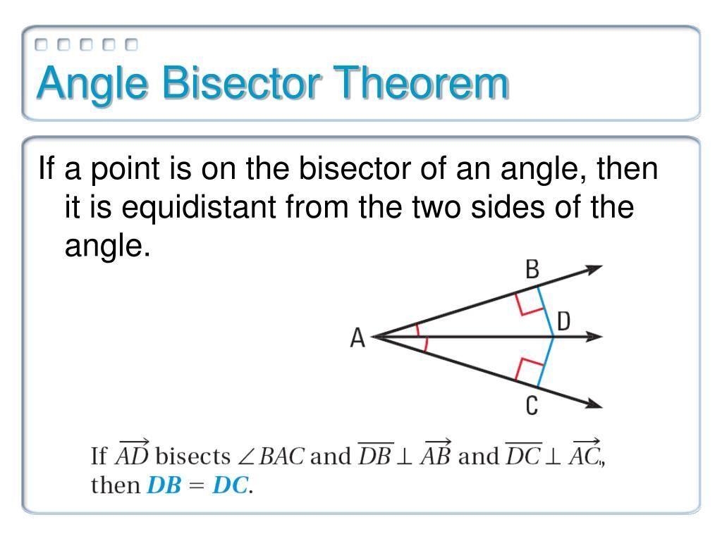
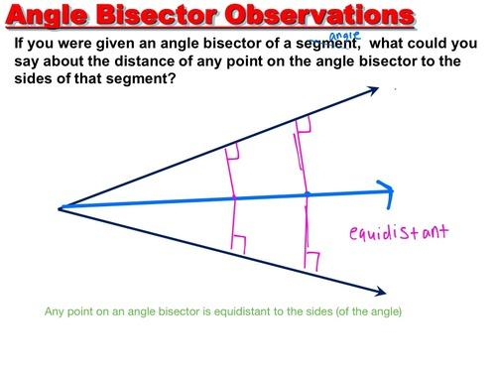
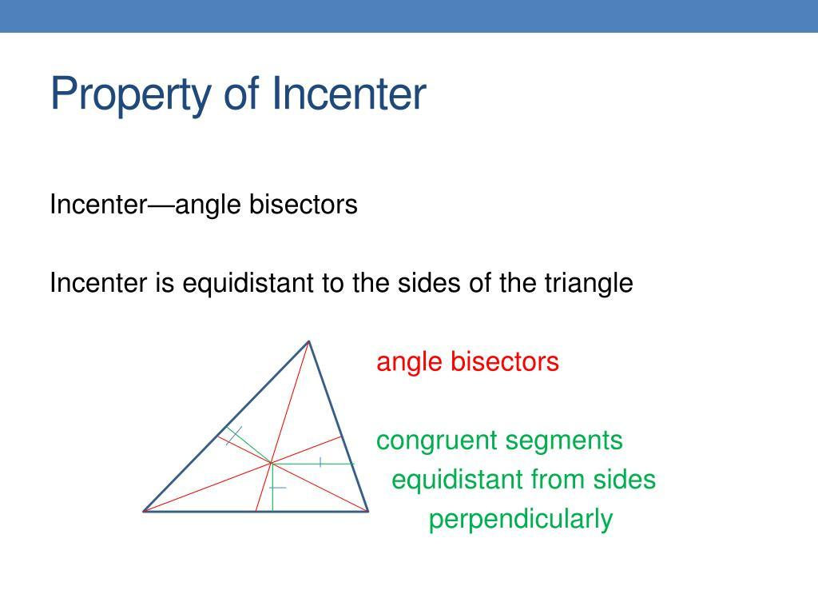

Relation to the Incenter
# Source: AI Source: Provided by: [Data Path: Persons Table -> ID Column: 1, Name_En Column: Motasem Essam] -> From: [ChatGPT] on [7/25/2026]
The incenter of a triangle is the point where the three internal angle bisectors intersect.
Because it lies on each angle bisector, its perpendicular distances from the three sides are equal:
$$\boxed{d\left(I , AB\right)=d\left(I , BC\right)=d\left(I , CA\right)=r}$$
where $r$is the inradius.
Thus, the incenter can be understood through the locus concept:
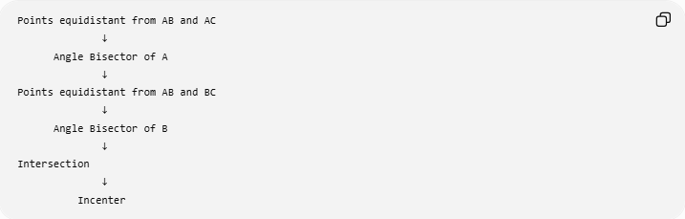
Points equidistant from AB and AC
↓
Angle Bisector of A
↓
Points equidistant from AB and BC
↓
Angle Bisector of B
↓
Intersection
↓
Incenter

Relation to the Incircle
# Source: AI Source: Provided by: [Data Path: Persons Table -> ID Column: 1, Name_En Column: Motasem Essam] -> From: [ChatGPT] on [7/25/2026]
If $I$is the incenter and:
$$d\left(I , AB\right)=d\left(I , BC\right)=d\left(I , CA\right)=r,$$
then a circle centered at $I$with radius $r$touches all three sides.
Therefore:
$$\boxed{\text{Incenter}+\text{Equal Side Distances}→\text{Incircle}}$$

Construction
# Source: AI Source: Provided by: [Data Path: Persons Table -> ID Column: 1, Name_En Column: Motasem Essam] -> From: [ChatGPT] on [7/25/2026]
To construct the locus of points equidistant from two intersecting lines:
- Identify the intersection point.
- Construct the angle bisector of one angle.
- Construct the angle bisector of its supplementary angle.
- The two resulting lines form the complete locus.
The two angle bisectors are perpendicular.
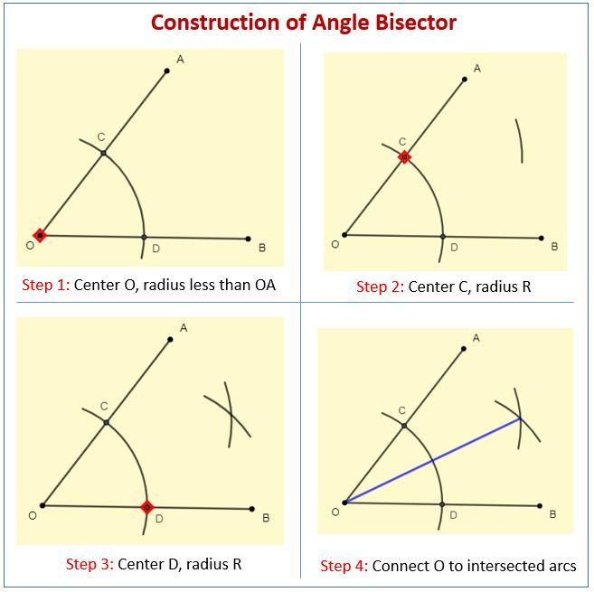
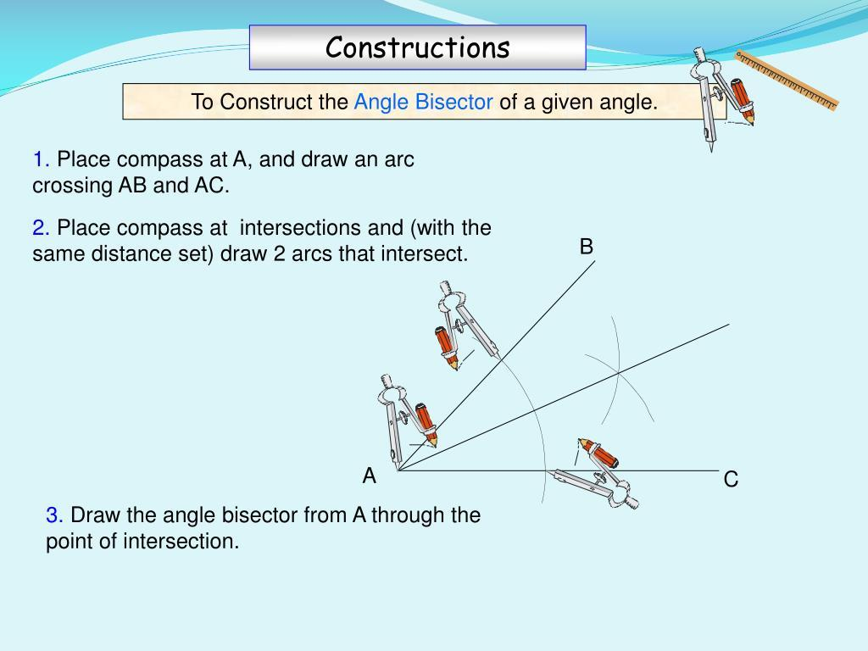
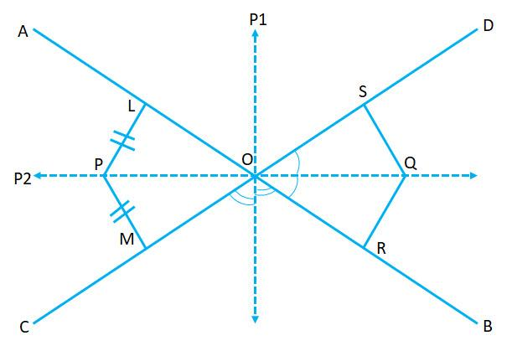
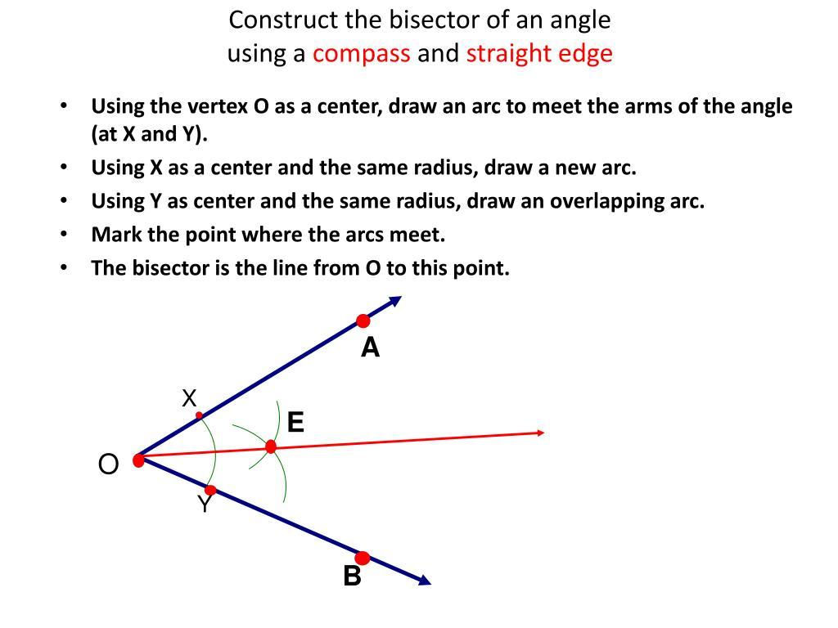

Important Property: Two Bisectors Are Perpendicular
# Source: AI Source: Provided by: [Data Path: Persons Table -> ID Column: 1, Name_En Column: Motasem Essam] -> From: [ChatGPT] on [7/25/2026]
Suppose the two original lines form an angle:
$$θ.$$
One bisector divides it into:
$$\frac{θ}{2}+\frac{θ}{2}.$$
The other bisector divides the supplementary angle:
$${180}^{∘}-θ$$
into:
$$\frac{{180}^{∘}-θ}{2}.$$
The angle between the two bisectors is:
$$\frac{θ}{2}+\frac{{180}^{∘}-θ}{2}={90}^{∘}.$$
Therefore:
$$\boxed{\text{The two angle-bisector lines are perpendicular.}}$$

Important Distinction: One Angle vs. Both Angles
# Source: AI Source: Provided by: [Data Path: Persons Table -> ID Column: 1, Name_En Column: Motasem Essam] -> From: [ChatGPT] on [7/25/2026]
Sometimes a problem asks for the locus inside a particular angle.
In that case, only the angle bisector of that particular angle is relevant.
For example, if the problem says:
Find the points inside $∠A$that are equidistant from its two sides.
The answer is:
$$\boxed{\text{The internal angle bisector of }∠A}$$
But if the problem asks:
Find all points in the plane equidistant from two intersecting lines.
The complete answer is:
$$\boxed{\text{Both angle-bisector lines}}$$

Comparison with Equidistance from Two Points
# Source: AI Source: Provided by: [Data Path: Persons Table -> ID Column: 1, Name_En Column: Motasem Essam] -> From: [ChatGPT] on [7/25/2026]
These two loci are easy to confuse.
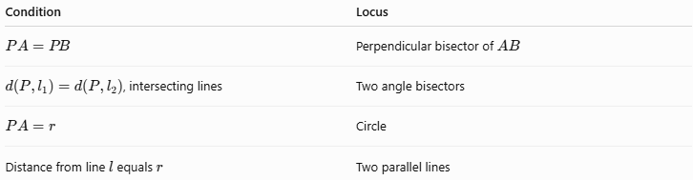
Condition | Locus
$$PA=PB$$ | Perpendicular bisector of $AB$
$d\left(P , l_{1}\right)=d\left(P , l_{2}\right)$, intersecting lines | Two angle bisectors
$$PA=r$$ | Circle
Distance from line $l$equals $r$ | Two parallel lines
The key distinction is:
$$\boxed{\text{Two Points}→\text{Perpendicular Bisector}}$$
while:
$$\boxed{\text{Two Intersecting Lines}→\text{Angle Bisectors}}$$

Classification
# Source: AI Source: Provided by: [Data Path: Persons Table -> ID Column: 1, Name_En Column: Motasem Essam] -> From: [ChatGPT] on [7/25/2026]
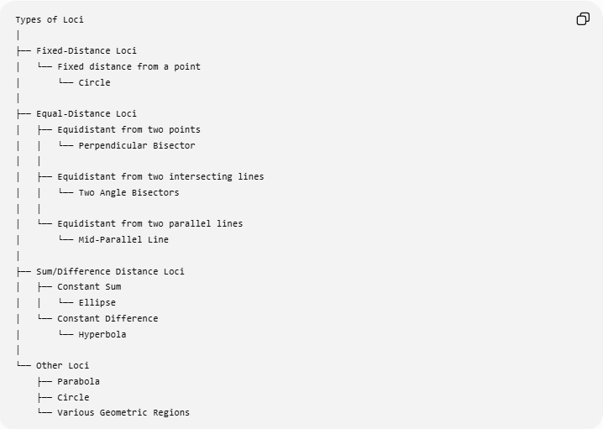
Types of Loci
│
├── Fixed-Distance Loci
│ └── Fixed distance from a point
│ └── Circle
│
├── Equal-Distance Loci
│ ├── Equidistant from two points
│ │ └── Perpendicular Bisector
│ │
│ ├── Equidistant from two intersecting lines
│ │ └── Two Angle Bisectors
│ │
│ └── Equidistant from two parallel lines
│ └── Mid-Parallel Line
│
├── Sum/Difference Distance Loci
│ ├── Constant Sum
│ │ └── Ellipse
│ └── Constant Difference
│ └── Hyperbola
│
└── Other Loci
├── Parabola
├── Circle
└── Various Geometric Regions

Key Formulas
# Source: AI Source: Provided by: [Data Path: Persons Table -> ID Column: 1, Name_En Column: Motasem Essam] -> From: [ChatGPT] on [7/25/2026]
Intersecting lines
$$\boxed{d\left(P , l_{1}\right)=d\left(P , l_{2}\right)}$$
gives the two angle bisectors.
Coordinate form
$$\boxed{\frac{∣a_{1}x+b_{1}y+c_{1}∣}{\sqrt{a_{1}^{2}+b_{1}^{2}}}=\frac{∣a_{2}x+b_{2}y+c_{2}∣}{\sqrt{a_{2}^{2}+b_{2}^{2}}}}$$
Coordinate axes example
$$\boxed{∣x∣=∣y∣}$$
giving:
$$\boxed{x=y \text{or} x=-y}$$
Parallel lines
For:
$$y=c_{1}, y=c_{2},$$
the locus is:
$$\boxed{y=\frac{c_{1}+c_{2}}{2}}$$
when $c_{1}≠c_{2}$.

Key Points
# Source: AI Source: Provided by: [Data Path: Persons Table -> ID Column: 1, Name_En Column: Motasem Essam] -> From: [ChatGPT] on [7/25/2026]
- The locus is based on equal perpendicular distances.
- For intersecting lines, the locus consists of two angle-bisector lines.
- The two angle-bisector lines are perpendicular.
- Every point on an angle bisector is equidistant from the two lines.
- Every point equidistant from two intersecting lines lies on one of their angle bisectors.
- For parallel lines, the locus is the single line halfway between them.
- This concept is fundamental to angle bisectors, incenters, incircles, and geometric constructions.

Conclusion
# Source: AI Source: Provided by: [Data Path: Persons Table -> ID Column: 1, Name_En Column: Motasem Essam] -> From: [ChatGPT] on [7/25/2026]
$$\boxed{\text{Equidistant from Two Intersecting Lines}→\text{Two Angle Bisectors}}$$
Thus, the locus of points equidistant from two intersecting lines is the pair of angle bisectors of those lines. If the lines are parallel, the locus changes to the single line exactly midway between them.

